Sri Lanka Institute of Information Technology



Lab Submission

<Lab sheet 10>

**<IT24101304>**

**<Fernando.S.A.W.>**

**Probability and Statistics| IT2120**

B.Sc. (Hons) in Information Technology

Exercise

1. i. State the null and alternative hypotheses for the test.

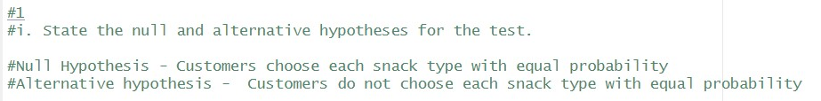

ii. Perform a suitable chi-squared test to test the null hypothesis.

iii. Give your conclusions based on the results.

